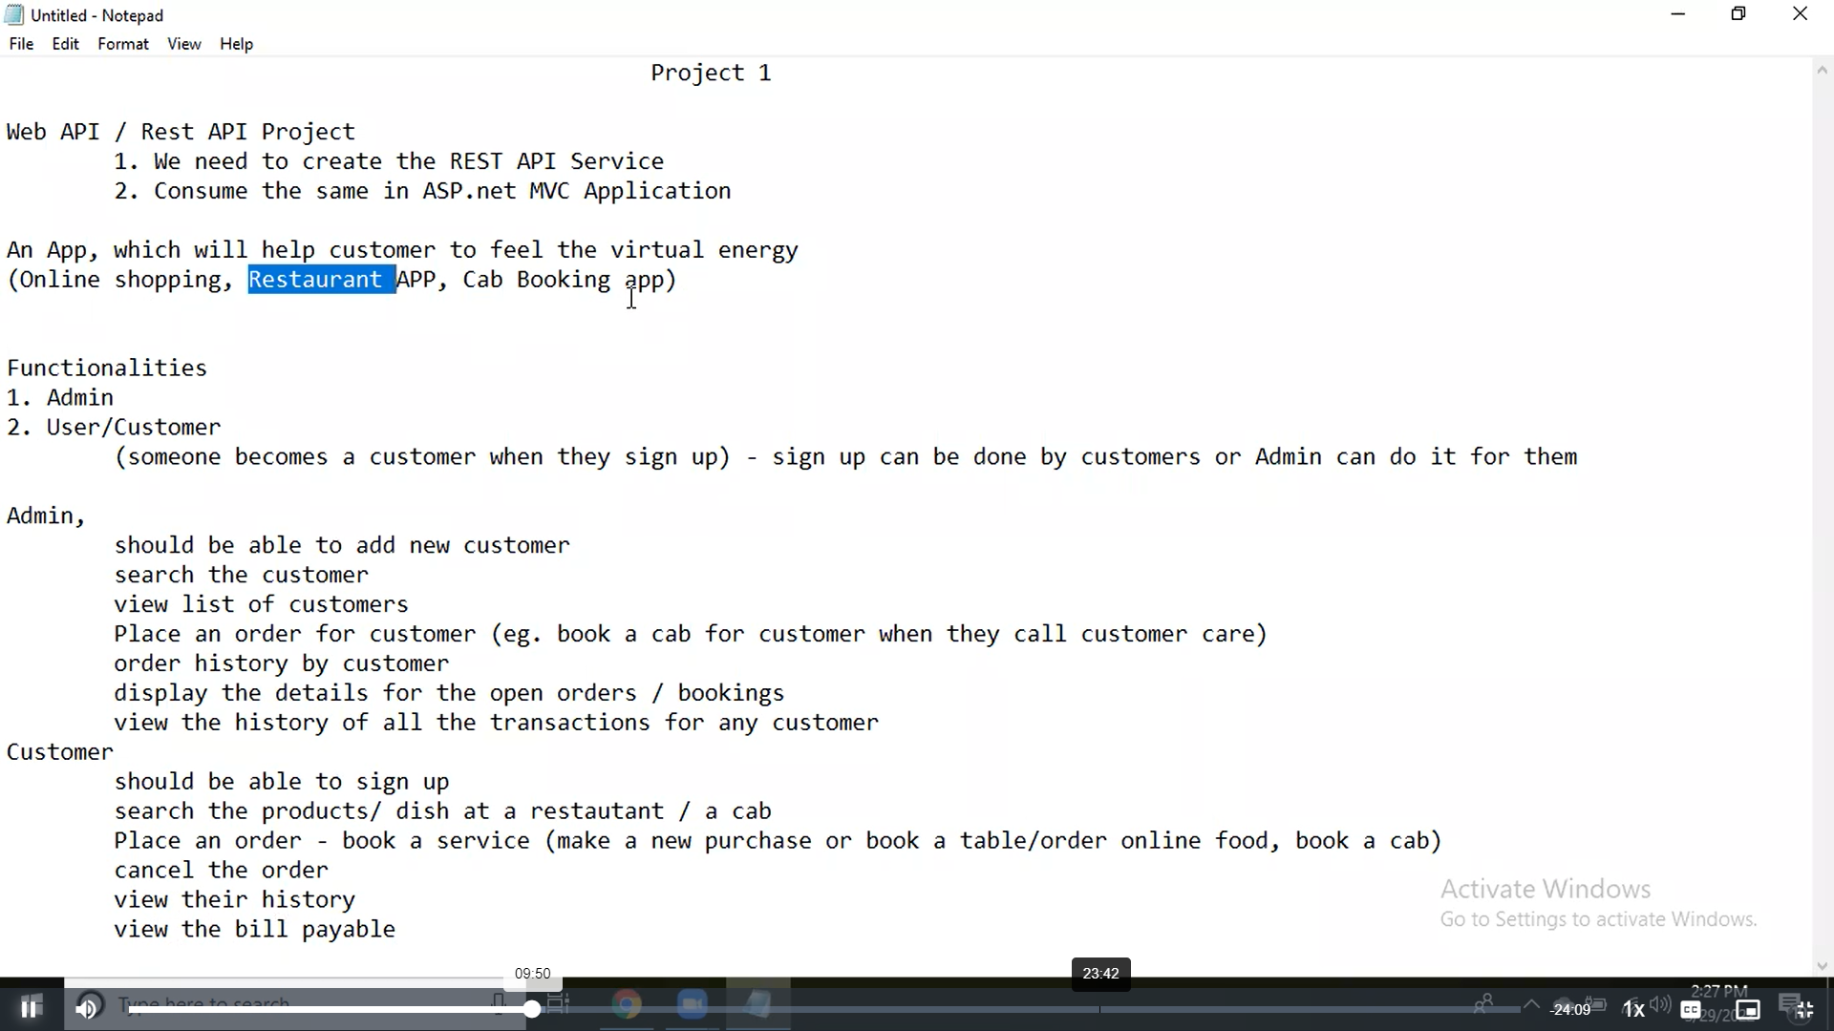

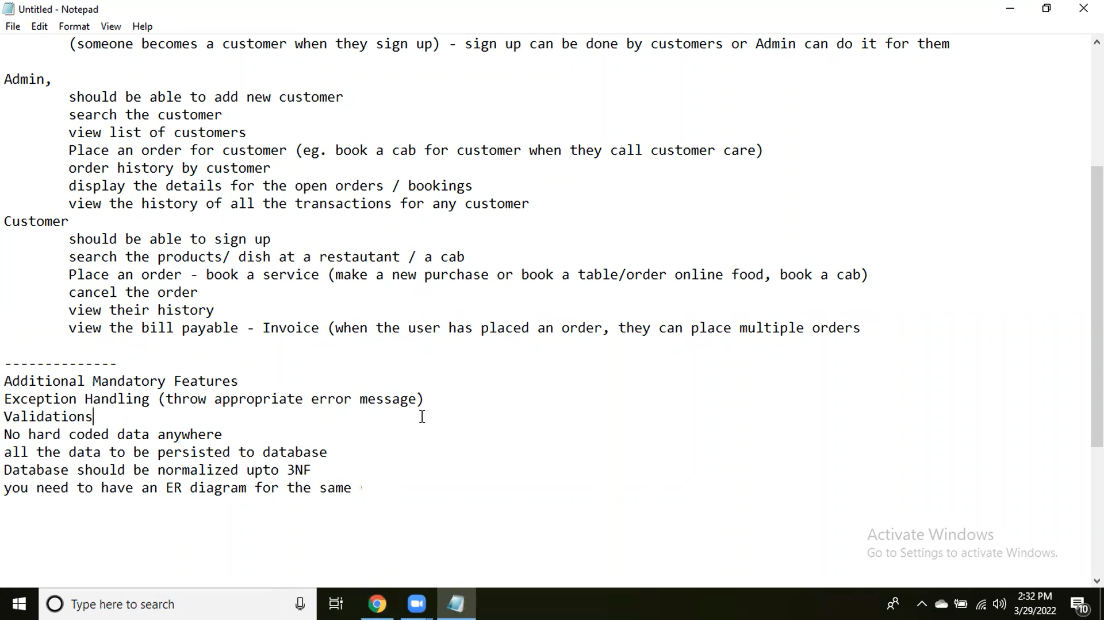

using System;

using System.Data.SqlClient;

using System.Collections.Generic;

namespace WelLives.WHmodels

{

public class ProductsInfo

{

#region fields

public int productID { get; set; }

public string pName { get; set; }

public double pPrice { get; set; }

public bool pIsInStock { get; set; }

public int pAvailableQty { get; set; }

#endregion

#region establish connection to database

SqlConnection Conn = new SqlConnection(@"server = SANCTA-MARIE\ISPM_TRAINING;database=Warehouse;integrated security=true");

#endregion

#region List of products

public List<ProductsInfo> GetAllProducts()

{

List<ProductsInfo> listOfProducts = new List<ProductsInfo>();

SqlDataReader productRead = null;

// How to define specific column? select (ID,Name)form Product

//

SqlCommand command_Read = new SqlCommand("select * from Product", Conn);

try

{

Conn.Open();

productRead = command_Read.ExecuteReader();

while (productRead.Read())

{

listOfProducts.Add(new ProductsInfo()

{

productID = Convert.ToInt32(productRead[0]),

pName = Convert.ToString(productRead[1]),

pPrice = Convert.ToDouble(productRead[2]),

pIsInStock = Convert.ToBoolean(productRead[3]),

pAvailableQty = Convert.ToInt32(productRead[4])

});

}

}

catch (SqlException readEx)

{

throw new Exception(readEx.Message);

}

finally

{

productRead.Close();

Conn.Close();

}

return listOfProducts;

}

#endregion

#region search product by Name

public ProductsInfo FindPrByName(string prName)

{

ProductsInfo yourProduct = new ProductsInfo();

SqlDataReader readTable = null;

SqlCommand cmd_Find = new SqlCommand("select * from Product where name = @Name", Conn);

cmd_Find.Parameters.AddWithValue("@Name", prName);

try

{

Conn.Open();

readTable = cmd_Find.ExecuteReader();

if (readTable.Read())

{

yourProduct.productID = Convert.ToInt32(readTable[0]);

yourProduct.pName = prName;

yourProduct.pPrice = Convert.ToDouble(readTable[2]);

yourProduct.pIsInStock = Convert.ToBoolean(readTable[3]);

yourProduct.pAvailableQty = Convert.ToInt32(readTable[4]);

}

else

{

throw new Exception(" Sorry, Product not found; try again soon, we are replenishing");

}

}

catch (Exception searchEx)

{

throw new Exception(searchEx.Message);

}

finally

{

Conn.Close();

}

return yourProduct;

}

#endregion

#region

public string AddNewCustomer(ClientOrders newCustomer)

{

SqlCommand command = new SqlCommand("insert into Customer values(@customerID,@begin_date,@name,@email,@phone,@address) ", con);

command.Parameters.AddWithValue("@customerID", newCustomer.customerID);

command.Parameters.AddWithValue("@begin_date", newCustomer.beginDate);

command.Parameters.AddWithValue("@name", newCustomer.customerName);

command.Parameters.AddWithValue("@email", newCustomer.email);

command.Parameters.AddWithValue("@phone", newCustomer.phoneN);

command.Parameters.AddWithValue("@address", newCustomer.address);

try

{

Conn.Open();

command.ExecuteNonQuery();

}

catch (SqlException exadd)

{

throw new Exception(exadd.Message);

}

finally

{

Conn.Close();

}

return " New Customer Added ";

}

#endregion

}

}

using Microsoft.AspNetCore.Http;

using Microsoft.AspNetCore.Mvc;

using WelLives.WHmodels;

namespace WelLives.Controllers

{

[Route("api/[controller]")]

[ApiController]

public class WHouseController : ControllerBase

{

ProductsInfo pInfo = new ProductsInfo();

#region Warehouse product list

[HttpGet]

[Route("list of all our products")]

public IActionResult listOfAllProducts()

{

return Ok(pInfo.GetAllProducts());

}

#endregion

#region Search product by name

[HttpGet]

[Route ("Your search product details")]

public IActionResult YourProductDetail(string prName)

{

try

{

return Ok(pInfo.FindPrByName (prName));

}

catch (System.Exception ex)

{

return BadRequest(ex.Message);

}

#endregion

#region Add a custome

[HttpPost]

[Route("Welcome New Customer")]

public IActionResult AddNewCustomer (ProductsInfo newCustomer)

{

try

{

return Created(pInfo.)

}

catch (System.Exception)

{

throw;

}

}

}

}

}

CREATE TABLE Authentification(

Username varchar(20) NOT NULL primary key,

[Password] varchar(20) NOT NULL,

[Level] varchar(20) NOT NULL

)

CREATE TABLE PRODUCT(

ProductID int not null primary key,

Name varchar(200) not null,

Category varchar(200),

Price float not null,

IsAvailable bit not null,

QuantityInStock int not null,

Location_ID int Foreign key references ShopLocation(LocationID)

)

CREATE TABLE ShopLocation(

LocationID int not null primary key,

Name varchar(20) not null,

Address1 varchar (200)not null,

Adrress2 varchar (20),

ZipCode varchar (20),

City varchar (20) not null,

Country varchar (20) not null

)